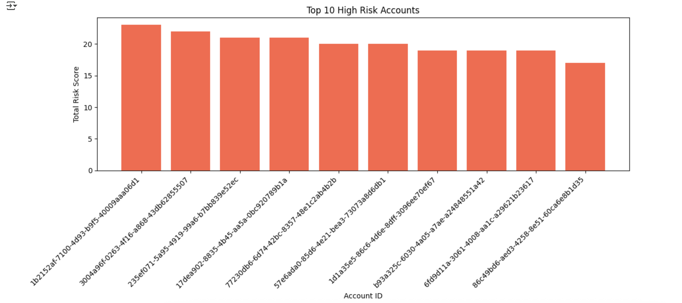

This bar chart highlights the top 10 savings accounts with the highest total risk scores based on rule-based metrics. These accounts stand out from the rest of the population, suggesting concentrated anomalous behavior such as frequent large withdrawals, abnormal transfers, or other rule violations. The significantly higher scores indicate that these accounts merit closer investigation for potential fraud or abuse.

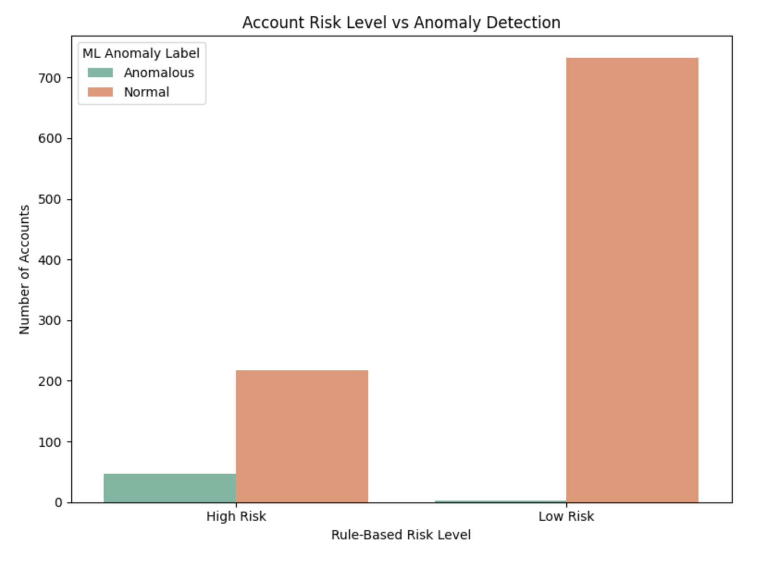

This chart compares the rule-based risk level of each account with the anomaly labels generated by a machine learning model. It reveals a strong alignment between accounts labeled as "High Risk" and those flagged as "Anomalous" by the model. In contrast, almost all "Low Risk" accounts were identified as normal, reinforcing the credibility of the rule-based system and supporting the model's validity as a second layer of detection.

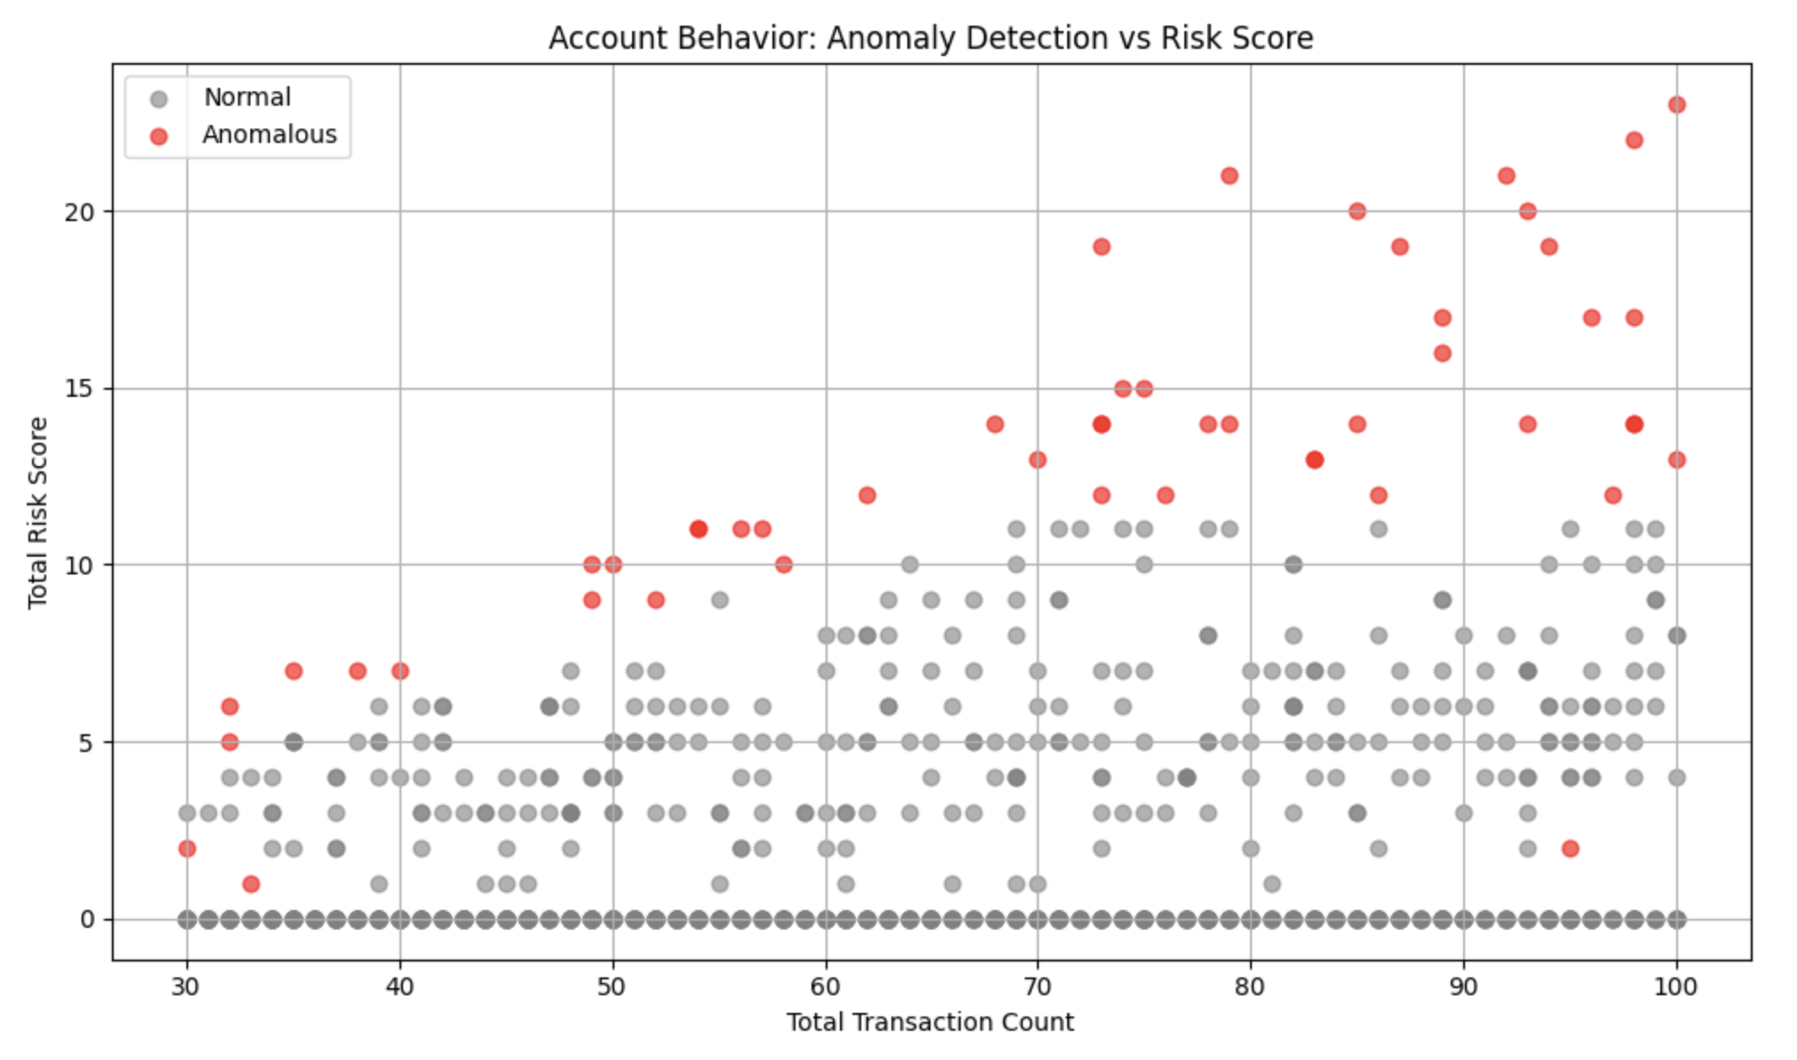

The scatter plot above visualizes the relationship between the total transaction count and the total risk score for each savings account, with anomalies identified by the machine learning model highlighted in red. It shows a clear positive correlation between transaction volume and risk score — as the number of transactions increases, the likelihood of a higher risk score also rises. Importantly, most anomalous accounts (in red) cluster in the upper-right region of the chart, suggesting that high-frequency, high-risk accounts are particularly prone to being flagged as anomalous. This reinforces the alignment between the rule-based scoring framework and the machine learning model's detection, as accounts with both high activity and elevated risk scores tend to be marked as outliers. However, there are also a few anomalies scattered at lower risk scores and transaction volumes, indicating that certain types of behavioral deviations may not directly correlate with volume or cumulative rule violations, and instead reflect nuanced or less common transaction patterns learned by the model.

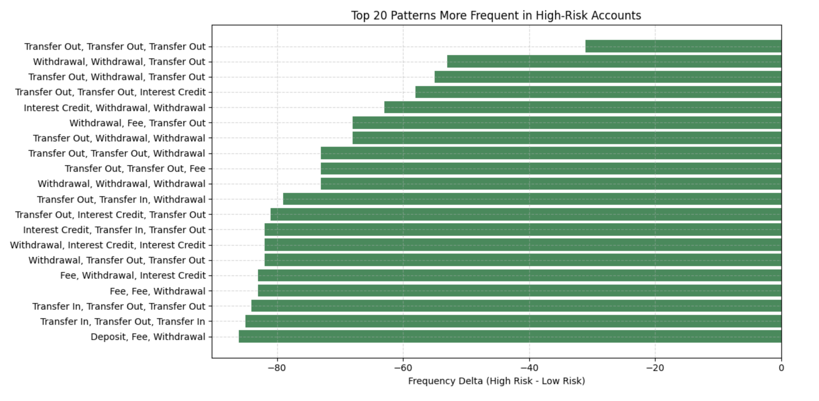

The horizontal bar chart presents the 20 most frequent 3-step transaction patterns in high-risk savings accounts compared to low-risk ones. Many of these patterns involve repeated sequences of withdrawals and outbound transfers, occasionally interleaved with interest credits or fees. These repetitive behaviors—such as "Transfer Out, Transfer Out, Transfer Out" or "Withdrawal, Withdrawal, Transfer Out"—may signal structuring, layering, or other suspicious activities, and could serve as valuable features for downstream fraud detection.